**Directions to the WVARA Winter Field Day Site**

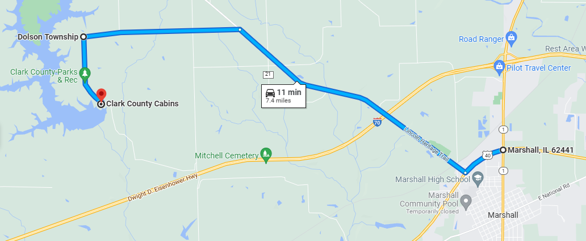

Go to the intersection of IL Route 1 and US Hwy 40 on the north side of Marshall, IL. The I-70 Marshall exit is Exit 147 (Illinois 1). US Hwy 40 is about 1 mile south of I-70.

Proceed 0.6 mile west to the first road on the right (Clarksville Road) and turn right (north).

Proceed 3.8 miles on Clarksville Road to 1900 Rd. There is a small grain bin sitting by itself in a field on your left just before you get to 1900 Rd. There is a small sign at this road:

Clark County Park District

Fay Pickering Memorial

Mountain Bike and Hiking Trails

Turn left (west) onto 1900 Rd and proceed 2.2 miles to where the road makes a hard left turn onto Hammer Road.

Proceed 1 mile on Hammer Road to the cabin on the right.

We'll have the W9UUU sign out.

Talk-in on the K9IKQ repeater (146.685 MHz, PL 151.4 Hz).