**Wabash Valley Amateur Radio Association, Inc.**

**Amateur Radio Classes**

**Maps & Driving Directions**

**YMCA of the Wabash Valley, 951 Dresser Drive, Terre Haute, IN**

*(In Fairbanks Park -- GPS Coordinates: 39° 27’ 24” N, 87° 23’ 06” W)*

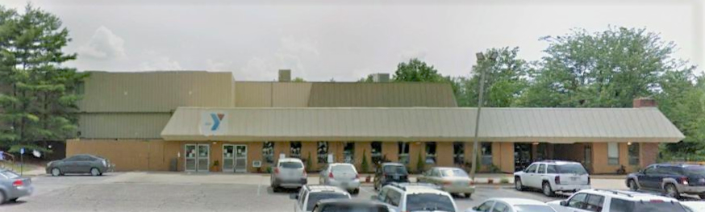

Entrance

|  |  |  |
| --- | --- | --- |
| YMCA |  | YMCA |

**Driving Directions**

**From the south (US 41, US 150, or I-70)**

* Go north on 3rd St (US 41 & US 150) to 5th stoplight north of I-70 (Farrington St.) Do not count stoplights for I-70 on/off ramps. Farrington St. is 1.7 miles north of I-70.
* Turn left (west) onto Farrington St.
* Go to stoplight (1st St.).
* Continue west on Dresser Drive into Fairbanks Park.
* The Vigo County YMCA will be the 1st building on your left.

**From the east or west (Wabash Ave or US 150)**

* Turn south on 1st St. (west side of Vigo County Courthouse)
* Go to 2nd stoplight (Farrington St/Dresser Drive)
* Turn right (west) into Fairbanks Park.
* The Vigo County YMCA will be the 1st building on your left.

**From the north (US 41 or IN 63)**

* Go south on 3rd St. (US 41) to Farrington St., which is 0.6 miles south of the courthouse.
* Turn right (west) onto Farrington St.
* Go to stoplight (1st St.).
* Continue west on Dresser Drive into Fairbanks Park.
* The Vigo County YMCA will be the 1st building on your left.

**Room Location**

* After entering the building, turn left into the 1st hallway.
* The room where the classes will be held is the last door on the left, immediately past the single door that is about ¾ of the way down the hallway.