WVARA Club Picnic Map & Driving Directions

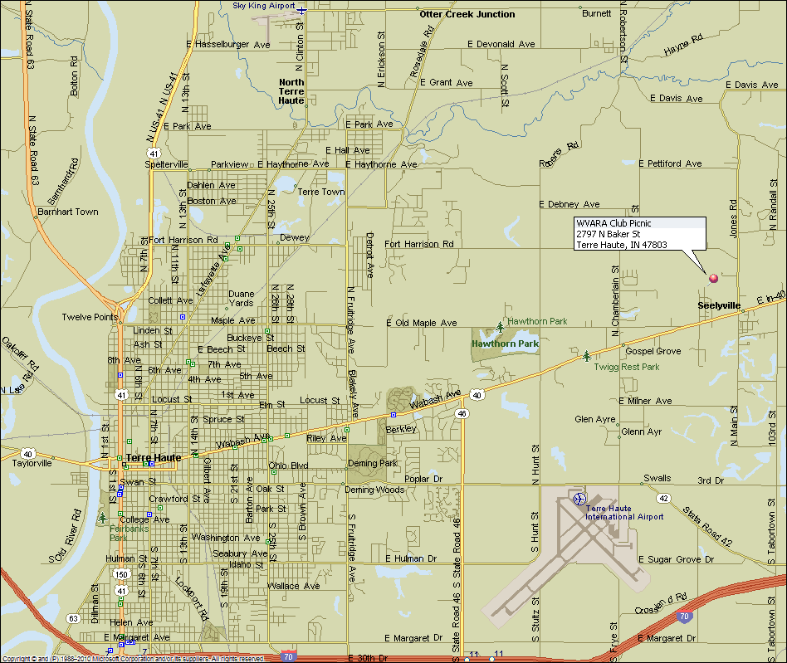
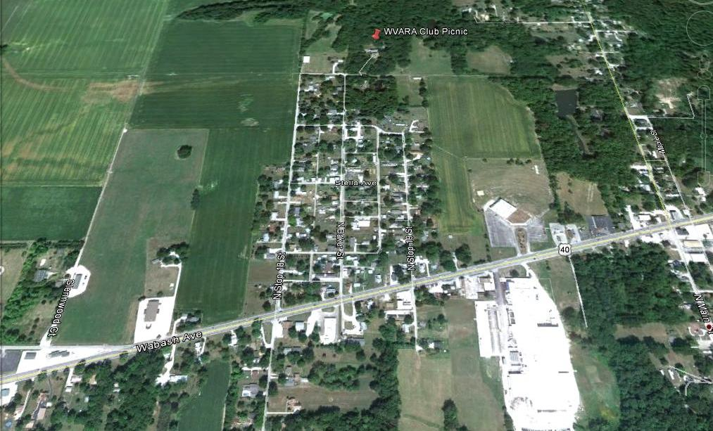
Driving Directions

From the West (Terre Haute):
- Go east on Wabash Avenue (US Hwy 40) to Baker St. (Seelyville)
  - Baker St is 3-1/4 miles east of SR 46.
- Turn north (left) onto Baker St.
- Go to end of street & turn right into driveway.

From the East (Brazil):
- Go west on US Hwy 40 to Baker St. (Seeleyville)
  - Baker St is 0.4 miles west of stoplight in Seeleyville.
- Turn north (right) onto Baker St.
- Go to end of street & turn right into driveway.

Talk-In on 146.685 MHz repeater (PL 151.4 Hz).

