Wabash Valley Amateur Radio Association, Inc.

Monthly Meeting Location

Terre Haute Salvation Army
234 S. 8th St – Terre Haute, IN 47807
Salvation
Army
Army
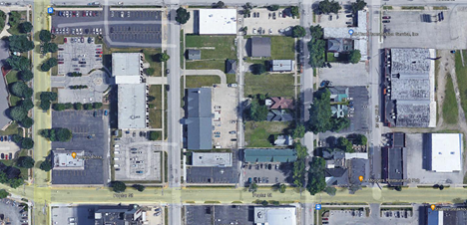
Salvation
Army
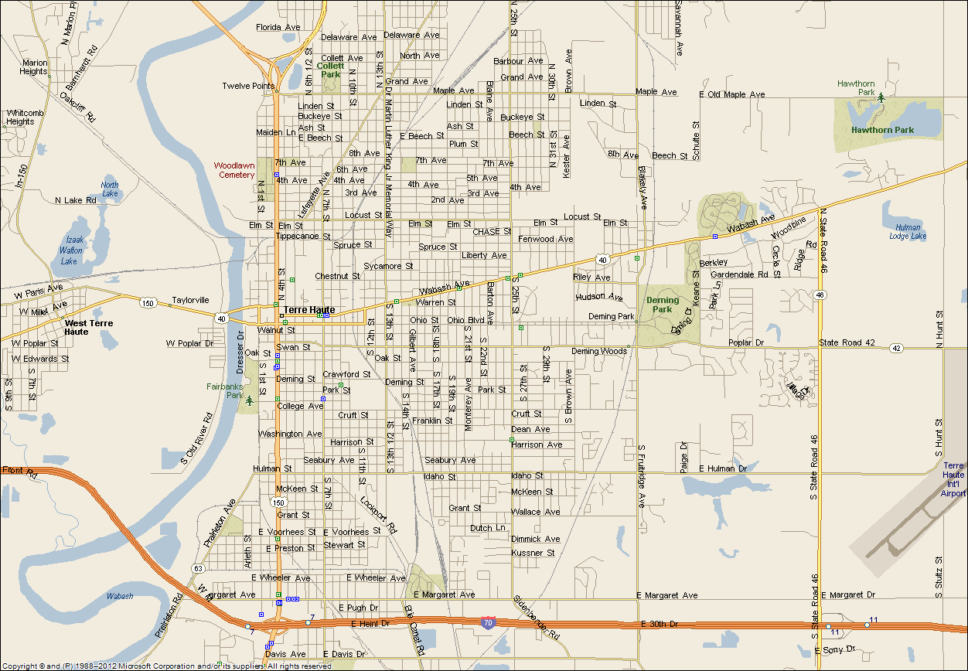
- From the north on 8th St. – Turn left into the driveway on the north side of the building just south of Walnut St.
- From the east or west on Poplar St. – Turn north into the alley between 8th St. & 9th St. Then turn left into the parking lot.
Salvation
Army
Army

